James Taylor

Assignment 5

University of Maryland University College

DATA610-9040 Summer 2019

Dr. Saleeb

james.taylor.ps3@gmail.com

**Introduction**

For this group assignment, we used the USNews dataset. In it there are 1,302 observations with 35 variables. Each observation is a US college from 1995. The attributes deal with standardized test scores, new student amounts and class rank, costs associated with attending the school, faculty of the school, expenditure of the institution and the graduation rate that school year.

There is a significant amount of data missing. For example, only 55% of observations have an average ACT listed. Other variables, like SAT scores, have even more empty values. I did not find egregious errors in our target error, graduation rate except for one observation. Cazenovia College is listed as having a 118% graduation rate. This won’t be included in our calculations or models.

**Exploration**

Graduation rate is a statistic colleges use to showing how many students receive degrees once they start their education there. This measure would not include students that transfer away to other institutions. In general, the better the graduation rate the more favorably the school is looked upon. This is because it indicates students don’t drop-out, fail classes needed to graduate or leave for opportunities elsewhere (the thinking being they leave because the school doesn’t meet expectations). *Figure 1-Graduation Rates* shows the distribution of graduation rates from the dataset. It appears to have a normal distribution, with mean of 60.12%. The lowest rate was 8% and the highest 100%.

Standardized tests are seen as reputable and fraudulent depending on who you ask. *Figure 2-ACT vs Gradation Rate* shows the relationship between ACT scores and graduation rate. There is a strong positive correlation between the two, the higher the average ACT the better the graduation rate is for that school.

References

USA Today Sports. (2017). Daytona 500 winners and speeds by year. USA Today. Retrieved from <https://www.usatoday.com/story/sports/nascar/2017/02/19/daytona-500-all-time-pole-qualifying-winners-speeds/97571726/>

Appendix A

Figure 1-Graduation

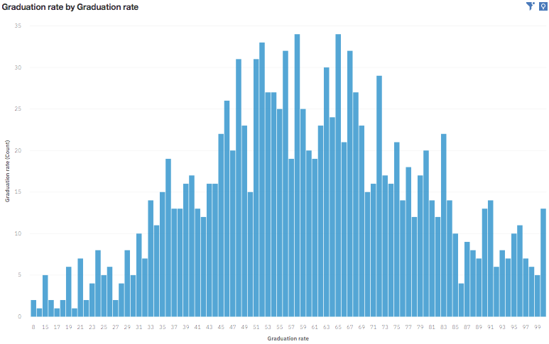

Figure 2-ACT vs Graduation Rate

